Karuta Game!

Target Grade:1-6
Target English: Vocab review!
Preparation: Picture cards
This is my variation of the traditional Japanese game. It is usually best played in the gym, but sometimes you can get away with it in the class room!!
Do a review of the words on the picture cards and then........
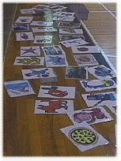
1. On one side of the room spread out lots of the picture cards.
2. On the other side of the room the kids form into 4 or 5 groups.
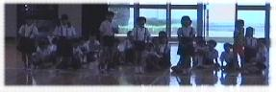
3. The kids line up in parallel lines so the first kid in each group faces the side
of the room where the cards are.
4. You say a word that is on one of the cards.
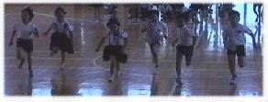
5. The first kid from each group runs forward towards the cards.
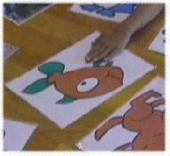
6.The first kid to slap their hand down on the correct card gets a point for their team.
7. These kids return to the back of their group's line. A set of new kids are now at the front.
8. Repeat from step 4.
Make sure you have some ground rules established. For example slapping other kids hands or pushing other kids out of the way results in the offenders team losing 2 points!! Also make sure they only slap their hand onto the cards, if they try and pick them up then the cards will get all messed up.
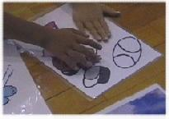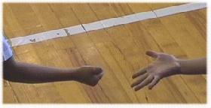
If there is confusion as to who touched the card first (here, two students got "baseball" at the same time), tell them to "janken" (the "paper, scissors, stone" game)
If there is a stage in the gym then setting the cards on the stage is a good idea. Accidents are reduced as the kids don't have to bend down to see the cards.

Readers' Comments:
To add variety and to stop accidents, get the kids to go to the cards in different styles e.g. hopping,jumping,stomping,star jumps,frog jumps etc.
Also, after playing many times and the kids are fully aware of the rules you can ask them to be teacher and decide on a movement and call out a flashcard.
I teach 3 and 4 year old and they have become experts!!!
Readers' Comments:
I've done a few variations on this game (before I even discovered your site!)
1) I actually had 'disposable' flashcards - always in multiples. I started with colours and shapes - each shape in ten colours but at least 4 of each.
I scattered them all over the floor and would call out "I want a red triangle". The kids would all dive in to find the 4 red triangles - when they find it they stand holding it high (and preferably tell me "red triangle...but they are only kinder kids). The kids loved scrambling about and it gave me a chance to see who was struggling - I would have plenty of kids grabbing the wrong colour, right shape or vice versa. You do need to watch it doesn't get too rough though so I really only play it with the young ones.
2) I have made about 60 flashcards of people wearing t-shirt, pants, socks, shoes each in different colour combinations, I send two runners to find "Who is wearing pink shoes?" They have 5 seconds to find as many with pink shoes as possible and then get that many points for their team.
I found the slightly older grades found a loop hole and would grab every card, letting me sort out which ones were right so I now say that any that are wrong equal that many points to the other team! It worked - they are quite careful now to not pick up the wrong card.
Obviously both of these are great ways to have the kids listen for two words in a sentence instead of one.

